1) What would happen if interrupts were checked and processed during the middle of an execution cycle instead of after the execution cycle has completed?

1. Before interrupt arrives, program A is executing. The program counter points to the current instruction.

2. When the interrupt is received by the CPU, the current instruction is completed, all the registers are saved in the stack area (or in a special known as a process control block). The PC is loaded with the starting location of program B, the interrupt handler program. This causes a jump to program B, which becomes the executing program.

3. When the interrupt routine is complete, the registers are restored, including the program counter, and the original program resumes exactly where it left off.

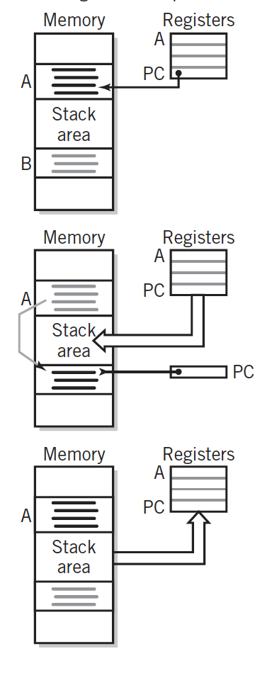

Reference:

1. The - Irv Englander *The Architecture of Computer Hardware and System Software A , 5th Edition,* Page 276.